Understandings, Applications and Skills (This is what you maybe assessed on)

 | Statement | Guidance
1.4.U1 | Particles move across membranes by simple diffusion, facilitated diffusion, osmosis and active transport.
1.4.U2 | The fluidity of membranes allows materials to be taken into cells by endocytosis or released by exocytosis.
1.4.U3 | Vesicles move materials within cells.
1.4.A1 | Structure and function of sodium–potassium pumps for active transport and potassium channels for facilitated diffusion in axons.
1.4.A2 | Tissues or organs to be used in medical procedures must be bathed in a solution with the same osmolarity as the cytoplasm to prevent osmosis.
1.4.S1 | Estimation of osmolarity in tissues by bathing samples in hypotonic and hypertonic solutions. (Practical 2) | Osmosis experiments are a useful opportunity to stress the need for accurate mass and volume measurements in scientific experiments.

Recommended resources:
http://bioknowledgy.weebly.com/14-membrane-transport.html
Allott, Andrew. Biology: Course Companion. S.l.: Oxford UP, 2014. Print.

1.4.U1 Particles move across membranes by simple diffusion, facilitated diffusion, osmosis and active transport.

- Define selectively permeable in the context of the plasma membrane.

- Define diffusion.

- Define osmosis.

- Distinguish between solute, solvent and solution.

- State four ways to maximize the rate of diffusion of a substance across a membrane.

- In the table below, tick the conditions required for each type of transport to occur.
 | Concentration gradient | Selectively permeable membrane. | Membrane proteins | ATP (source of energy)
Simple diffusion
Osmosis
Facilitated diffusion
Active transport

7. By which method does each of the following types of molecules travel across a membrane?

  - Water :
  - Non-polar molecules (with the concentration gradient) :
  - Polar molecules (with the concentration gradient) :
  - Any molecule against the concentration gradient :

- Osmosis occurs not just by simple diffusion, but also by facilitated diffusion.

  - State the name of the specialised type of membrane protein used to transport water.

  - Give examples of cells that use facilitated diffusion as well as simple diffusion.

  - Why is facilitated diffusion used if water can move by simple diffusion?

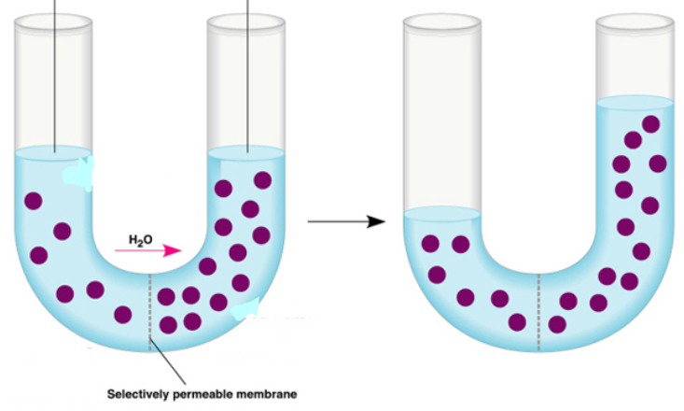
- Explain what is happening in this diagram:

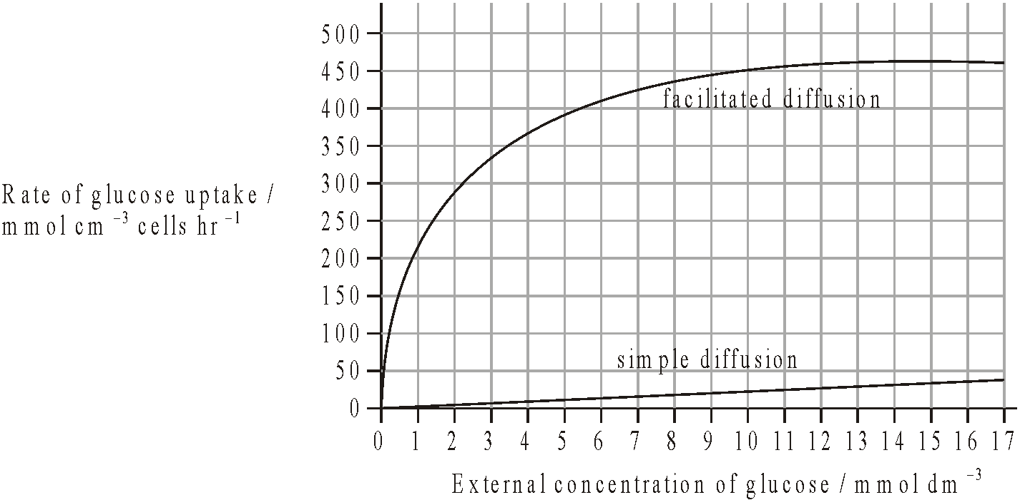
- A study was carried out to investigate the effect of passive protein channels on the movement of glucose into cells. The graph below shows the rate of uptake of glucose into erythrocytes by simple diffusion and facilitated diffusion.

  - Identify the rate of glucose uptake at an external glucose concentration of 4 mmol dm-3by
(i) simple diffusion. .........................................
(1)
(ii) facilitated diffusion. .........................................
(1)

(i) Compare the effect of increasing the external glucose concentration on glucose uptake by facilitated diffusion and by simple diffusion.
………...............................................................................................................................
………...............................................................................................................................
………...............................................................................................................................
………...............................................................................................................................
………...............................................................................................................................
………...............................................................................................................................
(3)

(ii) Predict, with a reason, the effect on glucose uptake by facilitated diffusion of increasing the external concentration of glucose to 30 mmol dm-3.
………...............................................................................................................................
………...............................................................................................................................
………...............................................................................................................................
………...............................................................................................................................
(2)

- In the space below, draw a diagram of a plant cell before and after plasmolysis. Explain how osmosis causes plasmolysis.

1.4.A2 Tissues or organs to be used in medical procedures must be bathed in a solution with the same osmolarity as the cytoplasm to prevent osmosis.

- What solutions, compared to cells can be described as isotonic, hyper or hypotonic. Define these terms:

  - Isotonic :
  - Hypertonic :
  - Hypotonic :

- Explain what would happen to the cells of tissues and organs immersed in these solutions:

  - Isotonic :
  - Hypertonic :
  - Hypotonic :

- List the common medical procedures in which an isotonic saline solution is useful:

1.4.U1 Particles move across membranes by simple diffusion, facilitated diffusion, osmosis and active transport. Cont’d

- ATP is the source of energy for active transport. Explain how ATP releases energy, using a simple diagram.

- Distinguish between uniport, symport and antiport as different methods of active transport. A simple diagram of each will help.

1.4.A1 Structure and function of sodium–potassium pumps for active transport and potassium channels for facilitated diffusion in axons.

The generation of a nervous impulse involves rapid movements of sodium and then potassium ions across the axon membrane. These movements occur by facilitated diffusion through sodium and potassium channels. Active transport is then used to restore the balance of ions ready for the net time an impulse needs to be generated.

- Annotate the diagram below to show how a protein pump is used in the active transport of sodium and potassium ions across the plasma membrane of axons.
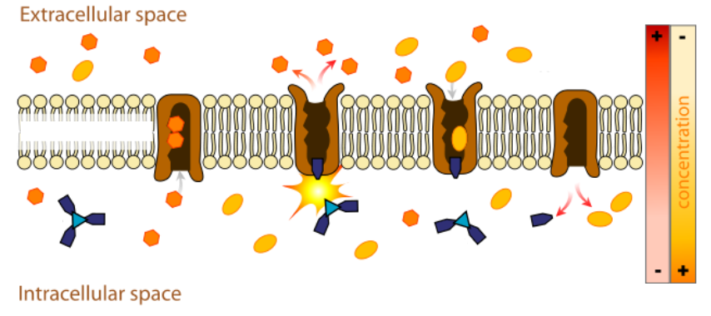

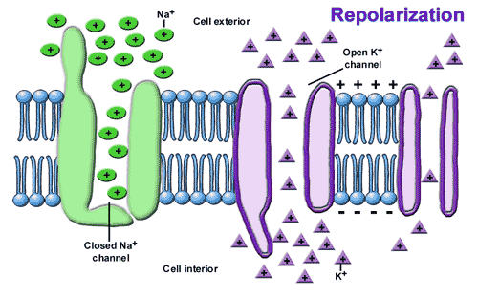
- Annotate the diagram below to show how protein channels are used in the facilitated diffusion of potassium in axons.

1.4.U3 Vesicles move materials within cells.

- What is a macromolecule? Give one example of a macromolecule produced in the cell.

- What is a vesicle?

- Outline the uses of vesicles within cells.

- Complete and annotate the diagram below to show the process of vesicle transport of a protein molecule through a eukaryote cell. Begin with protein synthesis in the Rough ER and finish with exocytosis though the plasma membrane. Label all organelles shown.

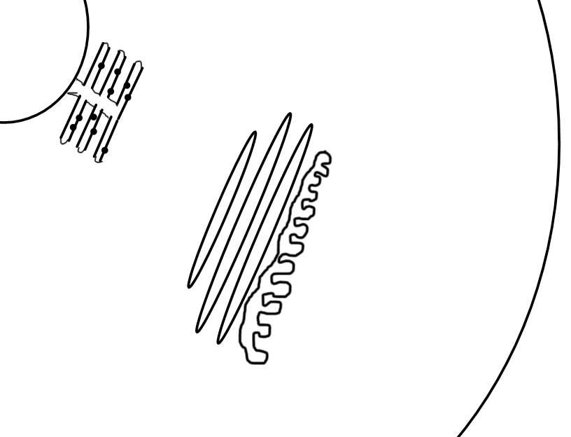

1.4.U2 The fluidity of membranes allows materials to be taken into cells by endocytosis or released by exocytosis.

- Differentiate between exocytosis and endocytosis.

- Exocytosis is often characteristised as being either pinocytosis or phagocytosis. Distinguish between between the two terms.

- Describe how the plasma membrane breaks and reforms during exocytosis and endocytosis. How does the fluidity of the membrane allow this?
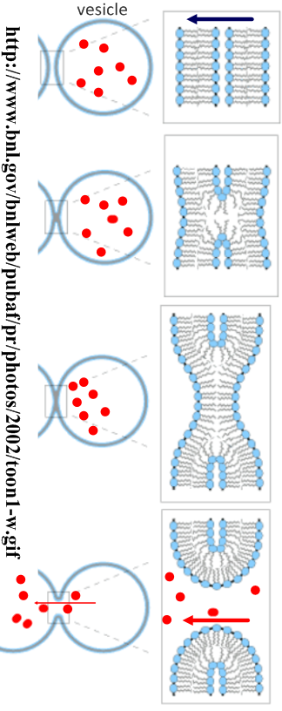

1.4.S1 Estimation of osmolarity in tissues by bathing samples in hypotonic and hypertonic solutions. (Practical 2)

[The below question is in addition to the lab and is used to test your understanding of the procedure. It is not a replacement for it.]

- An experiment was carried out to estimate the osmolarity of three different varieties of potato. 10mm diameter cores were taken from each variety and their masses recorded. After immersion in different concentrations of sodium chloride solution for six hours the cores were dried and re-weighed. The results are shown below:

Concentration of the sodium chloride solution  (+/-0.1M) | Percentage mass change of potato cores  (+/- 0.01%)
 | Variety A | Variety B | Variety C
0.0 | 12.34 | 14.38 | 13.03
0.1 | 5.86 | 10.14 | 7.73
0.2 | -3.7 | 6.56 | 4.88
0.3 | -13.34 | -0.5 | 0.81
0.4 | -20.43 | -5.73 | -6.73
0.5 | -24.53 | -10.77 | -13.68

  - Draw and label a graph to show the results. Your graph should include descriptive axis titles and linear best fit trend lines. (If graph plotting software is used then paste in the printed graph below)

  - Suggest a reason why % change in mass is plotted rather than the absolute change in mass or the final mass of the potato cores.

  - State whether water moved into or out of the different varieties of potato at 0.0M sodium chloride solution. Give evidence to support your answer.

  - State whether water moved into or out of the different varieties of potato at 0.5M sodium chloride solution. Give evidence to support your answer.

  - Deduce which variety of potato had the highest concentration of solutes in it’s cells.

  - Using the best-fit line estimate the osmolarity (in M of sodium chloride solution) of each variety of potato.

Variety A :
Variety B :
Variety C :

Citations:
Allott, Andrew. Biology: Course Companion. S.l.: Oxford UP, 2014. Print.

Cornell, Brent. 2.4 Membranes. Web. 24 Aug. 2014. <http://www.ib.bioninja.com.au/standard-level/topic-2-cells/24-membranes.html>.

Taylor, Stephen. "Essential Biology 02.4 Membranes.docx." Web. 24 Aug. 2014. <https://app.box.com/shared/1nhjmfssdq>.

