Topic 2.2 Energy and Biomass in An Ecosystem

Guiding Questions
- How can flows of energy and matter through ecosystems be modeled?
- How do human actions affect the flow of energy and matter, and what is the impact on ecosystems?
- What strategies can be employed to mitigate human impacts on the natural cycles of energy and matter in ecosystems?
- How do changes in land use affect the biogeochemical cycles and what are the implications for ecosystem health and sustainability?

Understandings | Class | Home | Got it
2.2.1 Ecosystems are sustained by supplies of energy and matter.
2.2.2 The first law of thermodynamics states that as energy flows through ecosystems, it can be transformed from one form to another but cannot be created or destroyed.
2.2.3 Photosynthesis and cellular respiration transform energy and matter in ecosystems.
2.2.4 Photosynthesis is the conversion of light energy to chemical energy in the form of glucose, some of which can be stored as biomass by autotrophs.
2.2.5 Producers form the first trophic level in a food chain.
2.2.6 Cellular respiration releases energy from glucose by converting it into a chemical form that can easily be used in carrying out active processes within living cells.
2.2.7 Some of the chemical energy released during cellular respiration is transformed into heat.
2.2.8 The second law of thermodynamics states that energy transformations in ecosystems are inefficient.
2.2.9 Consumers gain chemical energy from carbon (organic) compounds obtained from other organisms. Consumers have diverse strategies for obtaining energy-containing carbon compounds
2.2.10 Because producers in ecosystems make their own carbon compounds by photosynthesis, they are at the start of food chains. Consumers obtain carbon compounds from producers or other consumers, so form the subsequent trophic levels..
2.2.11 Carbon compounds and the energy they contain are passed from one organism to the next in a food chain. The stages in a food chain are called trophic levels.
2.2.12 There are losses of energy and organic matter as food is transferred along a food chain.
2.2.13 Gross productivity (GP) is the total gain in biomass by an organism. Net productivity (NP) is the amount remaining after losses due to cellular respiration.
2.2.14 The number of trophic levels in ecosystems is limited due to energy losses
2.2.15 Food webs show the complexity of trophic relationships in communities.
2.2.16 Biomass of a trophic level can be measured by collecting and drying samples.
2.2.17 Ecological pyramids are used to represent relative numbers, biomass or energy of trophic levels in an ecosystem.
2.2.18 Pollutants that are non-biodegradable, such as polychlorinated biphenyl (PCB), dichlorodiphenyltrichloroethane (DDT) and mercury, cause changes to ecosystems through the processes of bioaccumulation and biomagnification.
2.2.19 Non-biodegradable pollutants are absorbed within microplastics, which increases their transmission in the food chain.
2.2.20 Human activities, such as burning fossil fuels, deforestation, urbanization and agriculture, have impacts on flows of energy and transfers of matter in ecosystems.
HL Only
2.2.21 Autotrophs synthesize carbon compounds from inorganic sources of carbon and other elements. Heterotrophs obtain carbon compounds from other organisms.
2.2.22 Photoautotrophs use light as an external energy source in photosynthesis. Chemoautotrophs use exothermic inorganic chemical reactions as an external energy source in chemosynthesis.
2.2.23 Primary productivity is the rate of production of biomass using an external energy source and inorganic sources of carbon and other elements.
2.2.24 Secondary productivity is the gain in biomass by consumers using carbon compounds absorbed and assimilated from ingested food.
2.2.25 Net primary productivity is the basis for food chains because it is the quantity of carbon compounds sustainably available to primary consumers.
2.2.26 Maximum sustainable yields (MSYs) are the net primary or net secondary productivity of a system.
2.2.27 Sustainable yields are higher for lower trophic levels.
2.2.28 Ecological efficiency is the percentage of energy received by one trophic level that is passed on to the next level.
2.2.29 The second law of thermodynamics shows how the entropy of a system increases as biomass passes through ecosystems.

ECOSYSTEM PRODUCTIVITY AND ENERGY FLOW

- Watch the video on Ecosystems https://youtu.be/7cRgK0qG00E and answer the questions
  - Define ecosystem

  - State how ecosystems are classified

  - Suggest why ecosystems matter

- Outline the importance of energy and matter flow in an ecosystem

- List three examples of ecosystems and describe their primary energy sources

- Explain why ecosystems are considered an open system

- Watch the video Energy Literacy Essential Principle https://youtu.be/k6mX5uInCds and answer the questions
  - Suggest how energy literacy contributes to understanding and solving environmental issues

  - List some common forms of energy mentioned in the video

  - State how energy flow drives physical processes on Earth

  - State the primary sources of energy in the Earth system.

  - Give examples of how economic and political factors impact energy use and policy.

  - Suggest how individuals and communities influence energy consumption

  - Outline the potential benefits and drawbacks of different energy sources.

  - Suggest how improving energy literacy contributes to sustainable practices and environmental conservation

- Watch the video Guide to the Energy of the Earth https://youtu.be/fHztd6k5ZXY.
  - State the principles of energy conservation.

  - Outline the importance of the 1st Law of Thermodynamics

  - Draw a diagram depicting energy flow in the food chain.

- Define the principles of the 2nd Law of Thermodynamics

  - Outline the inefficiency of energy transformations.

  - Outline the implications of the 2nd Law of Thermodynamics

- Watch the video Relationship Between Photosynthesis and Respiration https://youtu.be/rXzN89I4_Yk. Compare and contrast photosynthesis and cellular respiration in a Venn diagram.

- Define photosynthesis: (Define: Give the precise meaning of a word, phrase or physical quantity)

  - state the word and chemical equation for photosynthesis (State: Give a specific name, value or other brief answer without explanation or calculation)

  - Annotate the diagram below to show the inputs, processes, transformations, and outputs associated with photosynthesis. (Annotate: Add brief notes to a diagram or graph)

- Define respiration: (Define: Give the precise meaning of a word, phrase or physical quantity)

  - state the word and chemical equation for respiration (State: Give a specific name, value or other brief answer without explanation or calculation)

  - Annotate the diagram below to show the inputs, processes, transformations, and outputs associated with respiration. (Annotate: Add brief notes to a diagram or graph)
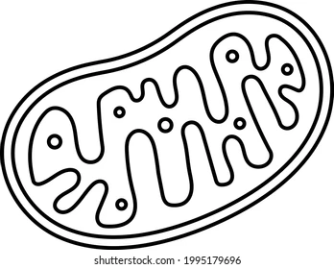

- Explain how the transfers of energy and matter through photosynthesis support the first and second laws of thermodynamics. (Explain: Give a detailed account of causes, reasons or mechanisms)

- Watch the video https://youtu.be/ZqzqFudrdeI Heat Released During Cellular Respiration
  - Create a pie chart showing the distribution of energy use and heat loss in cellular respiration.

- Activity: Create system diagrams from a set of data of ecosystems showing transfers and transformations of energy and matter.

Data for Terrestrial Ecosystem (Forest)
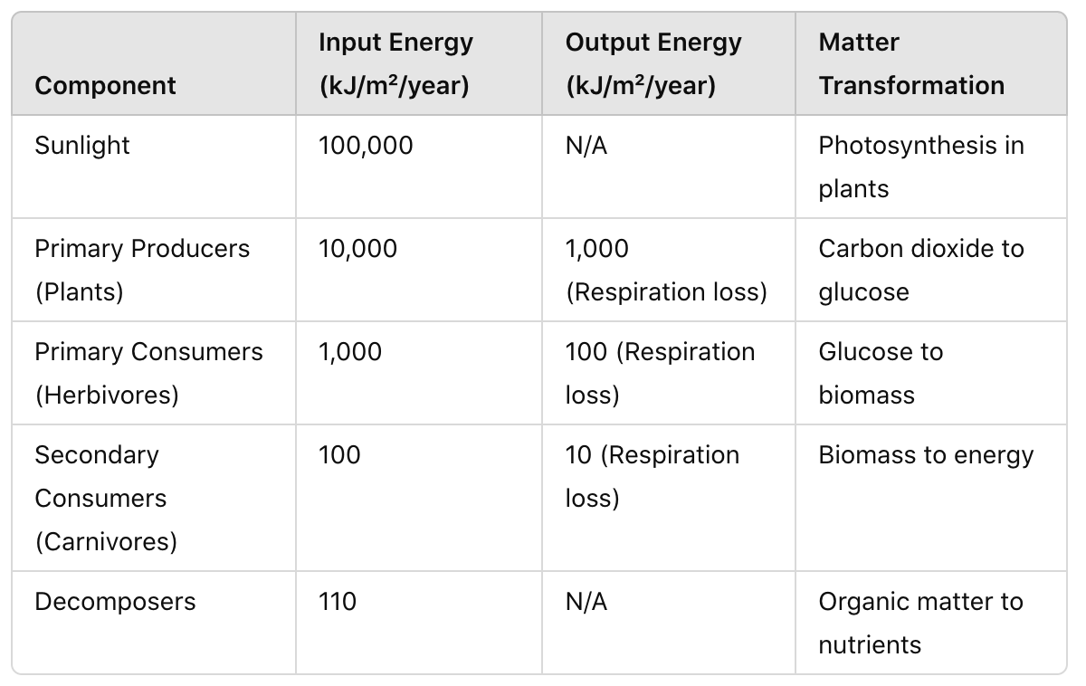

Data for Aquatic Ecosystem (Lake)
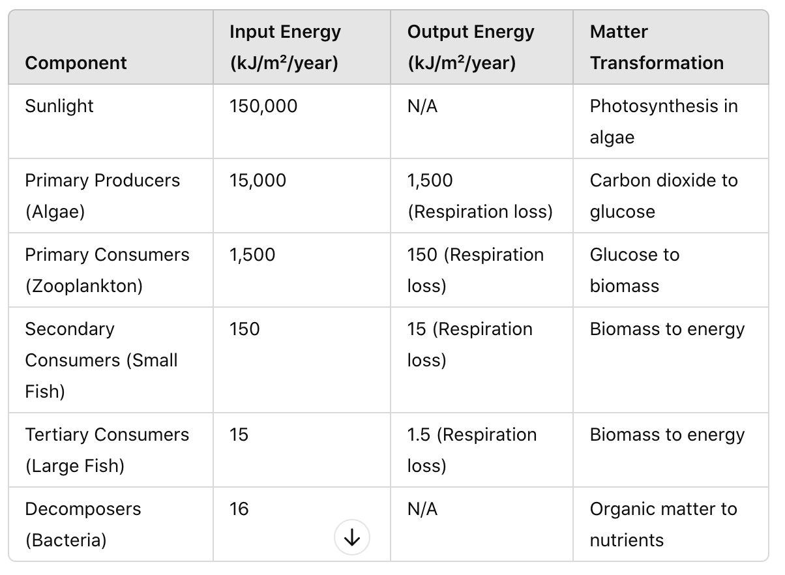

TROPHIC LEVELS
- Watch this video Trophic Levels Energy Transfer in Trophic Levels https://www.youtube.com/watch?v=0glkXIj1DgE&feature=emb_logo and answer the following questions
  - Define ‘trophic level’ (Define: Give the precise meaning of a word, phrase or physical quantity)

  - Suggest why it is sometimes difficult to classify organisms into trophic levels. (Suggest: Propose a hypothesis or other possible answer)

- Complete the table.
Group | Level | Energy Source | Importance | Example
Primary Producer | 1st | Solar energy  (autotrophs)
Primary Consumer | 2nd |  | - Disperse seeds  - Consume green plants and keep them in check through negative feedback loops
Secondary & Tertiary Consumers |  | Consume herbivores and other carnivores, sometimes PP
Predator

Parasites

Scavengers

Saprophytes |  | Dead organisms by secreting enzymes that break down organic matter | Both have the ecosystem service of  Breaking down dead organisms  Releasing nutrients to cycle  Controlling the spread of disease
Detritivores |  | Heterotrophs  (consume PP)

- Watch the video The Food Chain, https://youtu.be/5Z8rKhXUYAg and complete the following questions
  - State the primary components of a food chain

  - Suggest why food chains are important for understanding ecosystems.

  - State what happens to the energy as it moves from one trophic level to the next.

  - Suggest the impact human activities have on food chains.

- Activity: Individually brainstorm and select your own organisms to draw a food chain from given data. Include decomposers and detritivores in your food chains to illustrate the complete cycle of energy and nutrients in ecosystems (Draw: Represent by means of pencil lines)

- Activity - Draw a freshwater food web based on the following information: (Draw: Represent by means of pencil lines)
(You may need to research some of the organisms to learn what they are)

Organism | Energy sources
Water crowfoot | Sunlight
Cased caddisfly larva | Micro-plants, algae, particles of dead plants and animals
Damselfly nymph | Micro-plants, algae, particles of dead plants and animals
Mayfly nymph | Micro-plants, algae, particles of dead plants and animals
Dragonfly | Other adult insects and small flies
Duck | All nymphs, all plants, snails, tadpoles, young frogs
Freshwater Shrimp | Particles of dead plants and animals
Water vole | Plants
Algae | Sunlight
Otter | Fish, frogs, and newts
Water starwort | Sunlight
Pond snail | Microplants, all water plants, and algae
Alderfly nymph | Micro-plants, algae, particles of dead plants and animals
Pond skater | Particles of dead plants and animals
Frog | Mayfly, pond skater, caddisfly, small flies
Tadpole | Micro-plants, algae
Micro-plants | Sunlight
Great diving beetle | Water fleas, snails, tadpoles, all nymphs
Bullhead fish | Diving beetles, tadpoles, all nymphs, snails,

For the food web created above: (Draw: Represent by means of pencil lines)
  - Identify organisms in each of the trophic levels.
  - Identify organisms that fit more than one trophic level.
  - Identify those who could be classed as detritivores

- Watch the video The 10% Rule https://youtu.be/ScizkxMlEOM and answer the following questions
  - Define trophic efficiency

  - Explain the 10 Percent Rule

  - Describe what happens to the energy that is not transferred to the next trophic level.

  - State the implications of the 10 Percent Rule for ecosystem dynamics and stability.

- Activity: Using the provided data, each group will calculate the trophic efficiency between consecutive trophic levels. Use the formula:
  - Trophic Efficiency (%) = (Biomass or energy at higher trophic level / Biomass or energy at lower trophic level) * 100
  - Compare your results and identify any patterns or trends.
  - Discuss the implications of trophic efficiency on ecosystem dynamics and stability, emphasizing the importance of energy flow in sustaining ecological communities

Energy transfer between trophic levels in an aquatic ecosystem
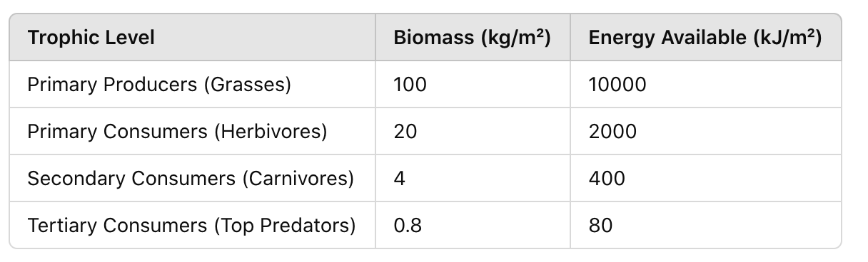

Energy transfer between trophic levels in a grassland ecosystem:
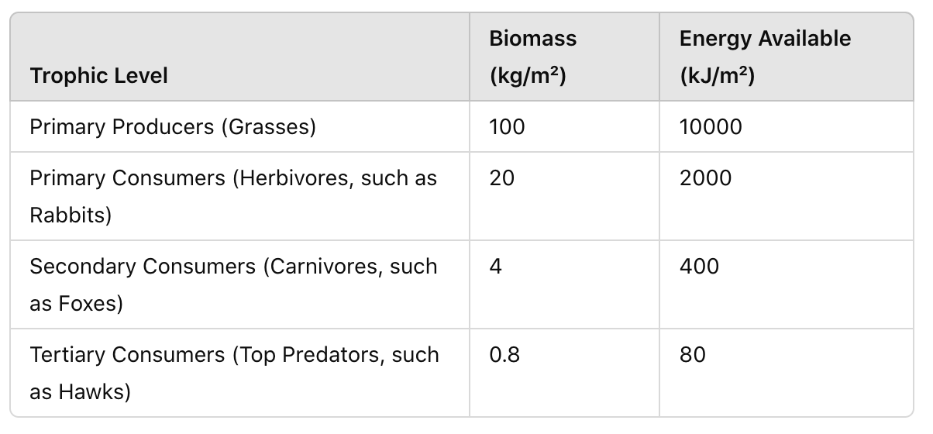

Energy transfer between trophic levels in an agriculture ecosystem
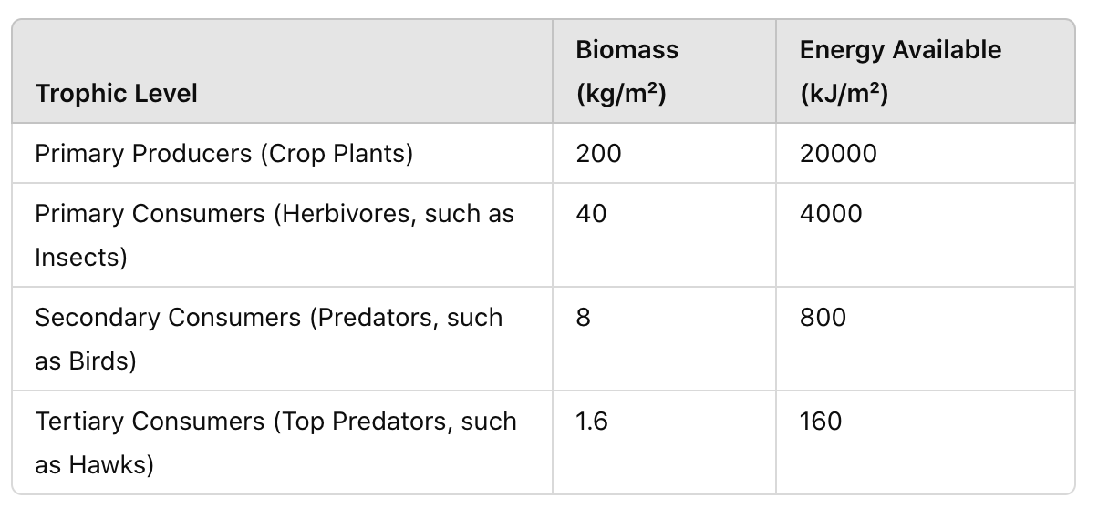

Productivity
- Define productivity.

- Compare gross productivity and net productivity with examples.
Gross productivity

Net productivity

  - Outline the importance of net productivity

- Calculate the gross productivity (GP) of a grassland ecosystem. It is measured to be 1000 kg/m^2/year (kilograms per square meter per year). Assume that approximately 40% of the gross productivity is lost due to respiration.
  - Respiration Loss = 40% of GP
  - Respiration Loss = 0.40 * 1000 kg/m^2/year
  - Respiration Loss = 400 kg/m^2/year

- Watch the video Ecological Pyramids https://youtu.be/nC1ZcUo7XoA and answer the following questions
  - Outline why ecological pyramids are important for understanding ecosystems.

  - Complete the table on the Ecological Pyramids

Type of Pyramid | Definition | Characteristics | Shape Variations
Numbers |  | vary greatly in shape. For example, in some ecosystems, there may be a large number of primary producers (e.g., grasses), followed by fewer herbivores (e.g., insects), and even fewer predators (e.g., birds).
Biomass |  |  | Inverted Biomass Pyramids: In some aquatic ecosystems, inverted pyramids of biomass can occur where the biomass of primary consumers (zooplankton) exceeds that of the primary producers (phytoplankton)..  Regular Biomass Pyramids: Typically, in terrestrial ecosystems, pyramids of biomass have a broad base and narrow top, reflecting the accumulation of biomass at the producer level and decreasing biomass at higher trophic levels.
Energy |  | always have a traditional pyramid shape because energy transfer between trophic levels is inefficient (approximately 10% efficiency), leading to a significant decrease in available energy at each successive level.

  - Why might a pyramid of biomass be inverted in some ecosystems?

- Pyramid of Numbers - Numbers (standing crop) units # of organisms at each trophic level per unit area N/m2. Evaluate the pyramid of numbers (Evaluate: Assess the implications and limitations)
Strengths | Weaknesses

- Pyramid of Biomass (standing crop) mass of organic material in organisms or ecosystems. Unit mass per unit area (g/m2). Evaluate the pyramid of biomass (Evaluate: Assess the implications and limitations)
Strengths | Weaknesses

- Pyramid Productivity (flow of biomass or energy over time) Unit – Joules or grams over an area over a time (J/m2/yr or g/m2/yr). Evaluate the pyramid of productivity. (Evaluate: Assess the implications and limitations)
Strengths | Weaknesses

- Activity: Using the following table, draw pyramids of numbers, biomass, and energy from the given data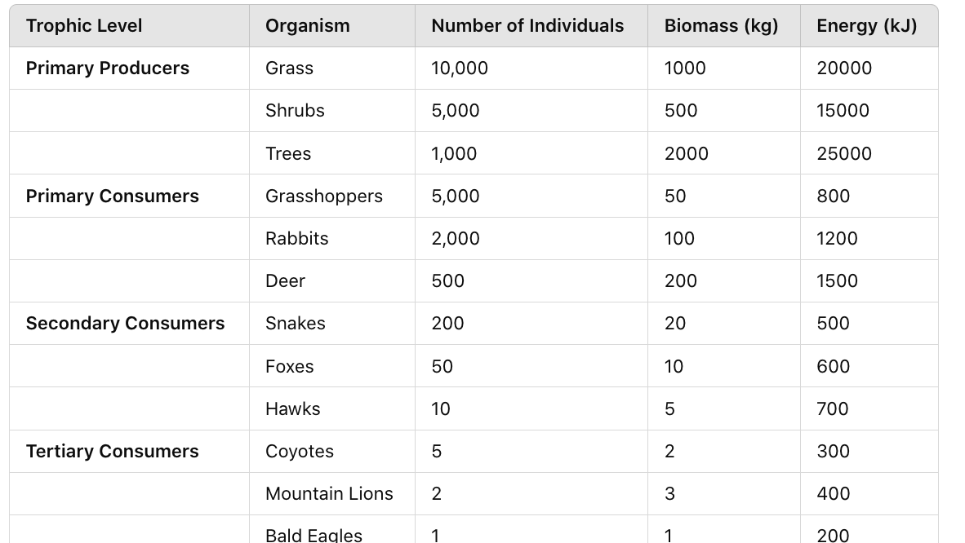

- Define biomass

- Outline the process of measuring biomass

- Activity: Follow experimental procedures on how to find biomass and energy from biological samples (plant material only).
  - Measuring Primary Productivity (Field Technique)
    - Choose a suitable study area, such as a grassland or forest.
    - Use quadrat frames to mark out sample plots (e.g., 1m x 1m).
    - Harvest all plant material within each quadrat.
    - Weigh the fresh biomass using a balance or scale.
    - Dry the plant material in an oven at 70°C for 48 hours to obtain dry biomass.
    - Measure the light intensity using a light meter at each quadrat site.
  - Measuring Secondary Productivity (Field Technique)
    - Capture herbivores (e.g., insects) from the sample plots using nets or traps.
    - Count the number of individuals collected.
    - Weigh the total biomass of the captured herbivores using a balance or scale.
  - Laboratory Analysis
    - For terrestrial plants, calculate GP using the increase in dry biomass over a specific time period.
    - For aquatic producers, calculate GP using changes in dissolved oxygen levels in light and dark bottles (light and dark bottle method).
    - Determine respiration loss by measuring the decrease in biomass or oxygen consumption in dark conditions.
    - Calculate NP using the formula: NP = GP - Respiration Loss

POLLUTANTS AND HUMAN IMPACT

- Define non-biodegradable

- Watch the video https://youtu.be/TZk6vcmLcKw Bioaccumulation and Biomagnification and complete the questions below
  - Distinguish between bioaccumulation and biomagnification (Distinguish: Give the differences between two or more different items).

  - List the types of substances that typically bioaccumulate in organisms.

  - State why these substances tend to accumulate in organisms over time.

- Watch this video on biomagnification and bioaccumulation in a California marine ecosystem https://youtu.be/FdPGRiYxKXg
  - Explain the impact of a persistent or non-biodegradable pollutant in the ecosystem (Explain: Give a detailed account of causes, reasons or mechanisms)

  - Suggest some of the ecological consequences of bioaccumulation and biomagnification.

  - Outline how these processes affect biodiversity and ecosystem stability.

  - Suggest why apex predators are significantly affected by toxins (Suggest: Propose a hypothesis or other possible answer)

- Research the impact of a specific pollutant on an ecosystem.

- Activity: Bioaccumulation simulation. This experiment is based on a simulation that was generously developed and made available to all by Virtual Biology Lab, located on the web at virtualbiologylab.org

- Outline plastic pollution

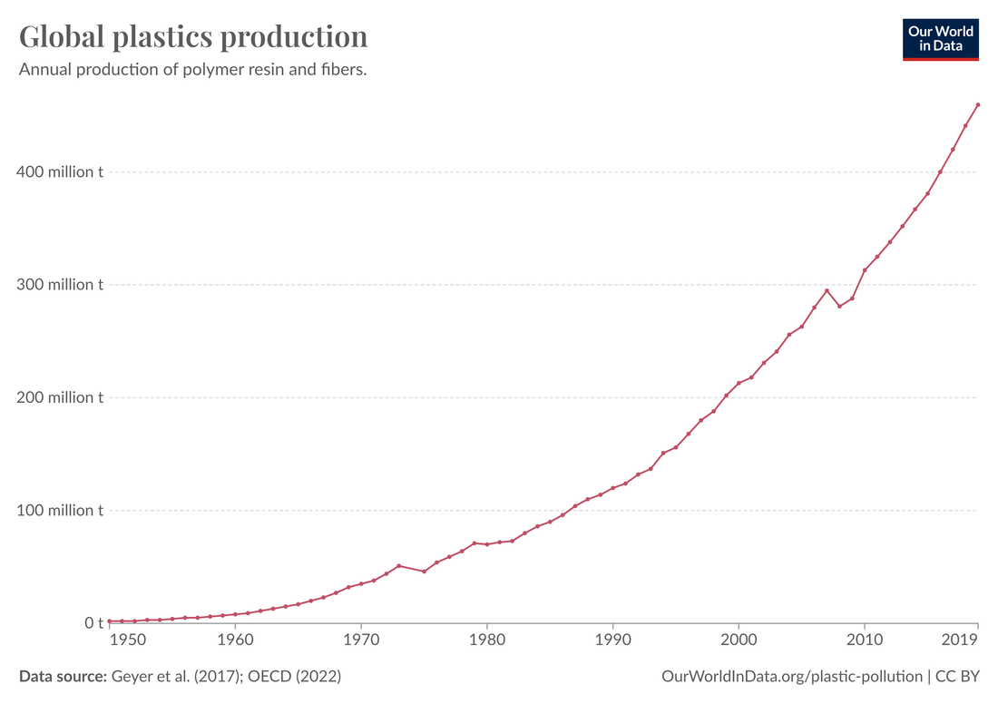

- Reference to the graph
  - Identify how global plastic production/pollution changed over the years.

  - Suggest how marine life and ecosystems are affected by the levels of plastic pollution shown in the graph

  - Suggest the socioeconomic impacts that might arise from the levels of plastic pollution shown in the graph.

  - Based on the trends observed, suggest actions that could be taken to reduce plastic pollution.

  - How reliable do you think the data presented in the graph is, and why

- Watch this video on Microplastics https://youtu.be/B_RBPAhx06w and answer the following questions
  - State how microplastics are defined

  - List the primary sources of microplastics

  - Outline how microplastics affect marine environments.

  - State the potential risks microplastics pose to human health.

  - Suggest solutions or strategies the video proposes to address the issue of microplastics.

- Outline how burning fossil fuels, deforestation, urbanization, and agriculture, have impacted flows of energy and transfers of matter in ecosystems.
Human Activity | Impact on Energy Flow | Impact on Matter Transfer | Examples of Consequences
Burning Fossil Fuels |  | Alters carbon cycle, leading to increased atmospheric CO2 and ocean acidification
Deforestation

Urbanization |  |  | Heat islands, increased runoff, habitat fragmentation
Agriculture | Increases energy input for machinery and fertilizers

HL Only
- Define autotrophs and heterogeneous

- Complete the following table of examples of Autotrophs and Heterotrophs
Autotrophs | Heterotrophs

- Use the Venn diagram to compare and contrast the characteristics of autotrophs and heterotrophs

- Complete the following table identifying the characteristics of Photoautotrophs and Chemoautotrophs
Feature | Photoautotrophs | Chemoautotrophs
Energy Source |  | Inorganic Chemical Reactions
Environment | Forests, Oceans
Example

- Define primary productivity

- Outline the various ways of determining primary productivity

- Define gross and net primary productivity
gross primary productivity

net primary productivity

- Reference the following table
Ecosystem | Primary Productivity (kg carbon/m²/year) | Ecosystem | Primary Productivity (kg carbon/m²/year)
Tropical rainforest | 2.20 | Agriculture Land | 1.00
Temperate forest | 1.25 | Coral Reefs | 2.50
Grassland | 0.65 | Tundra | 0.20
Dry Desert | 0.15 | Wetlands | 1.80
Ocean (open) | 0.20 | Coastal (Kelp forest) | 1.50

  - Create a graph of the data in the table and insert it below
  - Identify which ecosystems have the highest and lowest primary productivity.
  - Discuss the factors that might contribute to the differences in primary productivity among the ecosystems.
  - Why do tropical rainforests and coral reefs have higher primary productivity compared to deserts and tundras?
  - How do human activities, such as agriculture, impact primary productivity in different ecosystems?
  - What role does climate play in determining primary productivity in various ecosystems?

- Define gross and net secondary productivity
Gross secondary productivity

Net secondary productivity

- Discuss the role of NPP in supporting food chains.

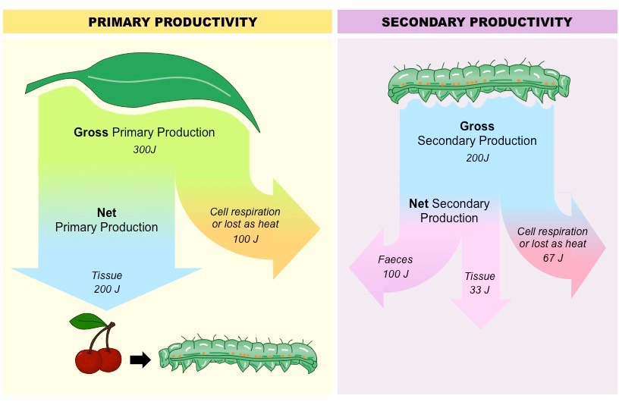

- Activity: Use laboratory and field techniques for measuring primary and secondary productivity and work out GP and NP from data
  - Measuring Primary Productivity (Field Technique)
    - Choose a suitable study area, such as a grassland or forest.
    - Use quadrat frames to mark out sample plots (e.g., 1m x 1m).
    - Harvest all plant material within each quadrat.
    - Weigh the fresh biomass using a balance or scale.
    - Dry the plant material in an oven at 70°C for 48 hours to obtain dry biomass.
    - Measure the light intensity using a light meter at each quadrat site.
  - Measuring Secondary Productivity (Field Technique)
    - Capture herbivores (e.g., insects) from the sample plots using nets or traps.
    - Count the number of individuals collected.
    - Weigh the total biomass of the captured herbivores using a balance or scale.
  - Laboratory Analysis
    - For terrestrial plants, calculate GP using the increase in dry biomass over a specific time period.
    - For aquatic producers, calculate GP using changes in dissolved oxygen levels in light and dark bottles (light and dark bottle method).
    - Determine respiration loss by measuring the decrease in biomass or oxygen consumption in dark conditions.
    - Calculate NP using the formula: NP = GP - Respiration Loss

- Define maximum sustainable yield

  - Discuss the challenges and benefits of maintaining MSY in natural resource management.

  - Complete the table MSY in different Ecosystems
Ecosystem Type | Species Harvested | GPP (kg/m²/year) | NPP (kg/m²/year) | MSY (kg/m²/year)
Marine Fishery |  |  | 200
Forest |  | 1000
Agriculture Field | Wheat |  |  | 200

- Outline the considerations for determining MSYs

- Watch the video How Does Your Diet Affect the Environment https://youtu.be/7Rufgoy9R2U, and complete the questions below
  - State why it is important to consider the environmental impact of our diet.

  - List the factors that contribute to the carbon footprint of food production.

  - State how the cultivation of different types of food affects deforestation and habitat loss.

  - Outline how livestock and plant-based foods compare in terms of greenhouse gas emissions.

  - State the role food waste plays in the environmental impact of our diet.

  - Suggest why consuming organisms from lower trophic levels, especially plants, is more sustainable

  - State how the video influenced your perspective on the relationship between diet and the environment.

- Create a food pyramid showing the sustainability of different trophic levels

- Define ecological efficiency

  - Write out the formula for ecological efficiency

  - Reference the following data,.
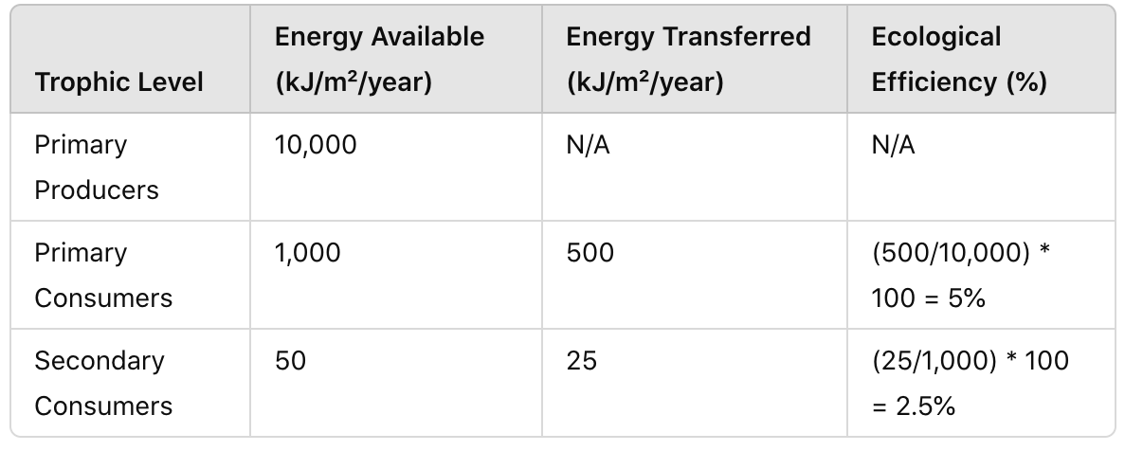
Terrestrial Ecosystem:

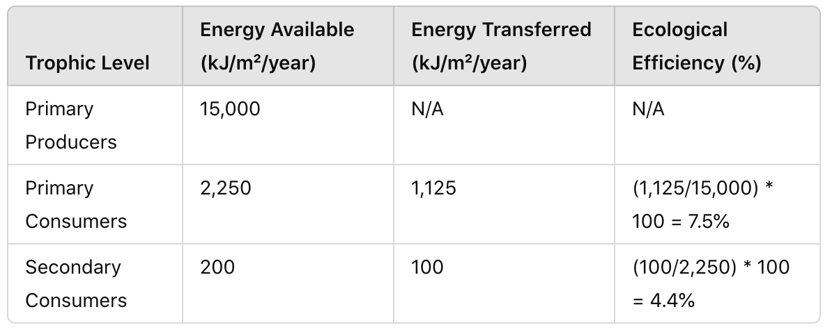
Aquatic Ecosystem:

  - Graph the ecological efficiency between two trophic levels in both terrestrial and aquatic ecosystems and insert below
  - Compare the ecological efficiency between the two ecosystems.
  - Identify which ecosystem has higher ecological efficiency and at which trophic level.
  - Suggest why you think the ecological efficiency differs between terrestrial and aquatic ecosystems.
  - State how environmental factors influence the ecological efficiency of these ecosystems.
  - Outline the implications of ecological efficiency for energy flow and food web stability in each ecosystem.

- Watch the video How Entropy Powers the Earth https://youtu.be/sAMlGyaUz4M and answer the following questions
  - Explain the concept of entropy

  - State why entropy is important for understanding how natural processes work.

  - Explain how entropy relate to the flow of energy in natural systems

  - State how the second law of thermodynamics is it explained in the video.

  - Give an example from the video where entropy plays a key role in a natural process.

  - Outline how the transformation of energy from one form to another increases entropy.

  - Suggest how human activities affect the natural flow of energy and entropy.

  - Describe an example that shows how ecosystems manage energy and entropy.

- Discuss the implications of entropy on ecosystem sustainability.

Reflection
Think about how energy flows and matter cycles in ecosystems. How do primary and secondary productivity, trophic levels, and ecological efficiency help keep ecosystems balanced?

ESS can be like learning a new language. So many words are not commonly used in everyday English. This can be challenging. To help you keep up with ESS Terms, you will need to create your own ESS DICTIONARY. You should add to this over the year and keep it in your notebook or on a page file THAT YOU CAN UPDATE AND ADD TO EASILY. Most of the vocabulary words can be found either on your STUDY GUIDE or at mrgscience.com.
You will be responsible for learning the words and their meaning. Periodic quizzes will be given on the words. So, make your dictionary creative and you will remember the words more easily.

KEY TERMS

Laws of Thermodynamics

photosynthesis

cellular respiration

conservation of energy

carbon compounds

organic matter

non-biodegradable

​biomass

sustainability

energy transfer

​trophic levels

bioaccumulation

​autotrophs

producers

food chains

food webs

​equilibrium

biomagnification
.
energy

gross productivity

​energy efficiency

ecological pyramids

​energy transformation

HL
heterotrophs

photoautotrophs

chemoautotrophs

secondary productivity

assimilated

net primary productivity

maximum sustainable yields

​ecological efficiency

entropy

